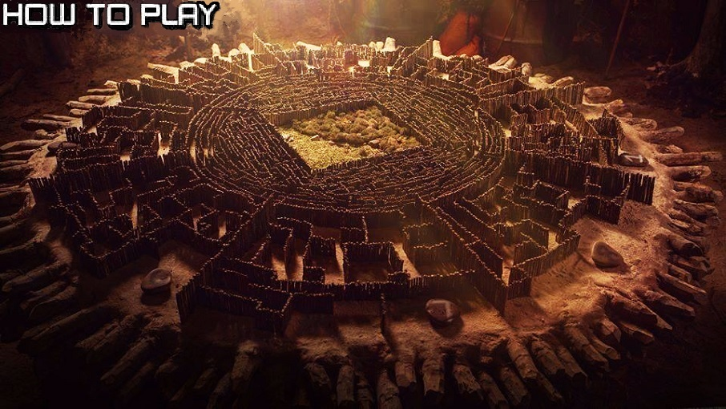 **TWO PLAYERS ARE PUT IN AN INVISIBLE MAZE**

**PLAYERS NEED TO RACE AND FIND THE RIGHT PATH GOING**

**TO THE APPLE IN ORDER TO WIN THE GAME**

**CONTROLS:**

**PLAYER 1: W-Up A-Left PLAYER 2:**

**S-Down D-Right USE ARROW KEYS**

